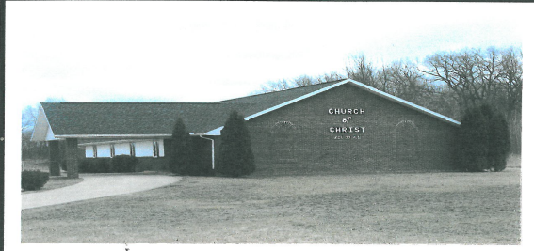
(B) = Birthday
(A) = Anniversary
Sunday | Monday | Tuesday | Wednesday | Thursday | Friday | Saturday
 |  |  |  |  |  | 1
2  Bible Study  10:15 a.m. – 10:50 a.m.  Worship 11 a.m. – 12 p.m.  *Quilting 3:00 p.m. -5:00 p.m. | 3 | 4 | 5 | 6 | 7 | 8
9  Bible Study  10:15 a.m. – 10:50 a.m.  Worship 11 a.m. – 12 p.m.  **Pot Luck | 10 | 11 | 12 | 13 | 14 | 15  *Clothes Closet & Food Pantry 10:00 a.m. – 12:00 p.m.
16  Bible Study  10:15 a.m. – 10:50 a.m.  Worship 11 a.m. – 12 p.m.  *Quilting 3:00 p.m. - 5:00 p.m.  * Business Meeting | 17 | 18 | 19 | 20 | 21 | 22
23  Bible Study  10:15 a.m. – 10:50 a.m.  Worship 11 a.m. – 12 p.m. | 24 | 25  (B) John Salyer II | 26  (B) Cheryl Whitaker | 27 | 28
February 2014

